**A**

**Project Report**

**on**

**"FLEX CONTROL ROBOTIC ARM"**

**Prepared by**

ANKIT BHIMANI (18EC010)

**Under the guidance of**

Prof. Rajat pandey and Prof. Riki Patel

**Submitted to**

Charotar University of Science & Technology for Partial Fulfillment of the Requirements for the Degree of Bachelor of Technology

in Electronics & Communication

EC 244 – Mini Project-II

of 4rd Semester of B.Tech

**Submitted at**



**DEPARTMENT OF ELECTRONICS & COMMUNICATION**

**Faculty of Technology & Engineering, CHARUSAT**

**Chandubhai S. Patel Institute of Technology**

**At: Changa, Dist: Anand – 388421**

**march 2020**

**CERTIFICATE**

This is to certify that the report entitled “**Flex Control Robotic Arm**” is a bonafide work carried out by Ankit Bhimani under the guidance and supervision of **Prof. Rajat Pandey** & **Prof. Riki Patel** for the subject **Mini Project-II (EC244)** of 4rdSemester of Bachelor of Technology in Electronics & Communication at Faculty of Technology & Engineering (C.S.P.I.T.) – CHARUSAT, Gujarat.

To the best of my knowledge and belief, this work embodies the work of candidate himself, has duly been completed, and fulfills the requirement of the ordinance relating to the Subject specified for 3rd semester of the University and is up to the standard in respect of content, presentation and language for being referred to the examiner.

Under the supervision of,

Prof. Rajat Pandey

Assistant Professor

Department of Electronics & Communication,

C.S.P.I.T., CHARUSAT-Changa.

Prof. Riki Patel

Assistant Professor

Department of Electronics & Communication,

C.S.P.I.T., CHARUSAT-Changa.

Dr. Trushit K. Upadhyaya

Head of Department,

Department of Electronics & Communication

C.S.P.I.T., CHARUSAT- Changa, Gujarat.

**Chandubhai S Patel Institute of Technology (C.S.P.I.T.)**

**Faculty of Technology & Engineering, CHARUSAT**

At: Changa, Ta. Petlad, Dist. Anand, Gujarat - 388421

EC010 Abstract

**ABSTRACT:**

A physically operating electronic apparatus which uses infrared radiation for their motion by

implementing specific connection such as preparing IR modules and connecting brian of robot.

The motor driver we used is called as the heart of our project. Excluded are other similar motor

drivers. It used in most of the industrial sectors to achieve production improvement, process

optimization and time and cost reduction. Integration, smartness and optimization are demanded to adapt to a rapidly changing and competitive market. In fact, standardization is a

key goal to achieve integration in this type of applications. This project is very used as transferring of goods and etc. The distance of IR sensors can change using potentiometer. The

principle is to reduce the time and cost. Its speed is fixed and dependent on the RPM of dc

motor used in the circuit.

C.S.P.I.T. i Department of electronics and Communication

EC010 Acknowledgement

**ACKNOWLEDGEMENT:**

I take this opportunity to express my profound gratitude and deep regards to my guide Prof. Rajat Pandey & Prof. Riki Patel and coordinator of E&C department of CSPIT, Prof. Trushit Upadhyaya, for their exemplary guidance, monitoring and constant encouragement throughout the course of this project. The blessing, help and guidance given by them time to time shall carry me a long way in the journey of life on which I am about to embark.

Ankit Bhimani (18EC010)

CSPIT, CHARUSAT

C.S.P.I.T ii Department of Electronics and Communication

EC010 Table of Content

**TABLE OF CONTENT**

Abstract…………………………………………………………………………………….i

Acknowledgement………………………………………………………………………...…...ii

List of Figures…………………………………………………………………………….iii

Abbreviations ………………………………………………………………………………..iv

**Chapter 1: Introduction of Project...……..……………………………………………..1**

1.1 Problem…..………….…………………………………………………………….1

1.2 Solution………...………………………………………………………………….1

1.3 Literature Survey………………………………………………………………….2

**Chapter 2: Project Description (Hardware)...………………………………………....3**

2.1 Block Diagram…………………………………………………...……………….3

2.2 Circuit Diagram…………………………………………………………………..4

**Chapter 3: Components and Its Details…………... ………………………………….5**

3.1 List of Components………………..…………………………………….……….5

3.2 Details of components……………… ………………………………….………..7

**Chapter 4: Implementation………………………... ………………………………….9**

4.1 Hardware Implementation…..……..…………………………………….…….....9

4.2 PCB Design in Software ……….…………………………….……………..…...10

C**hapter 5: Applications and Future scope.......…... …………………………………..14**

5.1 Applications…………….…..……..…………………………………….……….14

5.2 Future Scope.……………. ……………… …………………………….……….14

**Conclusion……….………………………………………….……………………………15**

**Reference………………………..………………………………………………………..16**

**Datasheets of Components…….………….……………………………………………..17**

C.S.P.I.T iii Department of Electronics and Communication

EC010

**LIST OF FIGURES:**

Figure 1 Block Diagram

Figure 2 Circuit Diagram

Figure 3 IC LM358

Figure 4 RESISTOR 1K

Figure 5 RESISTOR 100 OHM

Figure 6 RESISTOR 10K

Figure 7 IR TX

Figure 8 10K Potentiometer

Figure 9 DC motor

Figure 10 IC 7805

Figure 11 LED

Figure 12 Battery

Figure 13 IR RX

Figure 14 Wires

Figure 15 IC L293D

Figure 16 Project on bread board

Figure 17 Project on GPCB

Figure 18 PCB Software Implementation

Figure 19 PCB Software Implementation 3D view

Figure 20 Datasheets

List of Figures

Page number

3

4

5

5

5

5

5

5

6

6

6

6

6

6

6

9

9

10

13

17

C.S.P.I.T iii Department of Electronics and Communication

EC010 Abbreviations

**ABBREVIATIONS:**

TX Transmitter

RX Receiver

IC Integrated Circuits

PCB Printed Circuit Board

CSPIT Chandubhai S Patel Institue Of Technology

CHARUSAT Charotar University Of Science And Technology

C.S.P.I.T iv Department of Electronics and Communication

**CHAPTER 1: INTRODUCTION OF PROJECT**

There are different types of Industrial Transfer Systems in the electronics branch but the major transfer Systems are line followers only.

**1.1 PROBLEM:**

Classical line following robot is slow response to the error occur will easily leave its track that drawn on the floor. This problem will cause the motion of thre robot to be unsmooth. Although the line following robot can follow the black lines, Its motion still needs to be improved.

* In Industries , transfer of goods by workers which takes time and cost .
* In domestic purposes (like floor cleaning)not accurate and perfectly clean .

**1.2 SOLUTION:**

Sensing a line for the robot to stay on course, while constantly correctingwrong moves using feedback mechanism forms a simple yet effective closed loopsystem. As a programmer, we get an opportunity to “teach” ‟ the robot how to follow the line thus giving it a human-like property of responding to stimuli. Practical applications of a line follower: Automated cars running on roads with embeddedmagnets; guidance system for industrial robots moving on shop floor etc.

* For transfer of goods in fixed path, we can use this type of robots to reduce time and cost .
* For domestic purposes (like floor cleaning) we can use this type of robots .

**1.3 LITERATURE SURVEY:**

The line follower is a self-operating robot that detects and follows a line that is drawn on

the floor .The line follower robot using Arduino is a self-operating system that detects and

follows track drawn on the floor. The track consists of a black path drawn on white surface.

1.3.1 Path Following

Path following research can be separated into two main categories: research involving road vehicles and research involving smaller robots. The following sections give a brief overview of the research in both categories.

1.3.2 Road Vehicles

Due to the large cargo spaces available in the vehicles considerable processing resources can be applied to the path following problem, thus path following techniques using real road vehicles tend to use complex processing algorithms.

1.3.3 Smaller Robots

As the size of these robots prohibit the use of high performance computational equipment the algorithms used for path following are simpler than those used in the full sized road vehicles. However, for the most part, the same basic approaches are used though there is a greater emphasis on simulation.

1.3.4 Problems with These Methods

While all of the above methods are capable of functioning in an industrial environment, they are not suited to one. Many of the methods for example, rely on one or more desktop computers to perform the image processing and vehicle control computations. Those solutions using models of the environment require even more computing power. Such computational devices cannot easily be mounted on a mobile robot platform using current technology.

**CHAPTER 2: PROJECT DESCRIPTION (HARDWARE)**

**2.1 BLOCK DIAGRAM:**

This circuit of line follower robot is without microcontroller-based. Here we describe a line follower robot without microcontroller for those who are not familiar without microcontrollers. It is a simple project, which can be taken up as a classroom assignment. It lays the foundation for building your own [behaviour -based](https://en.wikipedia.org/wiki/Behavior-based_robotics) (simulated) robot. The robot uses interfaces for the sensors to make the behaviour of the robot as versatile as possible. Two light detectors are mounted at the front of the robot. Also, a path is provided for the robot to follow—either a black track (using black colour tape) on a white floor or a white track on a black floor.

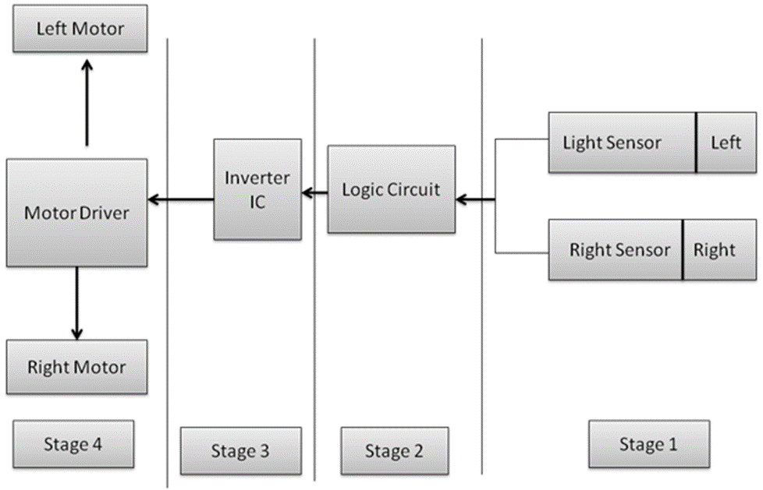 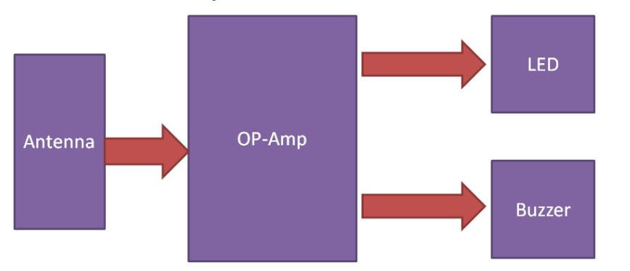

FIGURE 1:BLOCK DIAGRAM

**2.2 CIRCUIT DIAGRAM:**

Fig. 2 shows the circuit of the line follower robot. It comprises two TX and RX reflective optical sensors, inverter 74LS04, motor driver L293D , regulator 7805 and a few discrete components. TX and RX optical sensors are used as line follower robot sensors. The TX and RX reflective sensor includes an infrared emitter and photo-transistor in a leaded package. When an object comes in the sensing area, the emitted IR light reflects off the object back to the photo-transistor. So the amount of light energy reaching the detector increases. This change in light energy or photo-current is used as the input signal to activate the motors of the line follower robot.

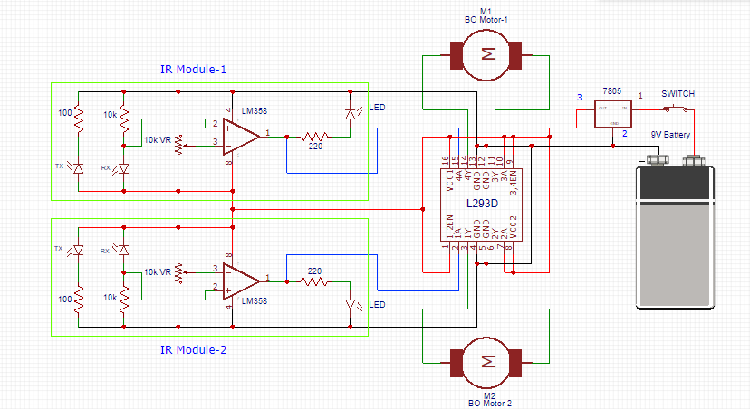

FIGURE 2:CIRCUIT DIAGRAM

**CHAPTER 3: COMPONENTS AND ITS DETAILS**

**3.1 LIST OF COMPONENTS:**

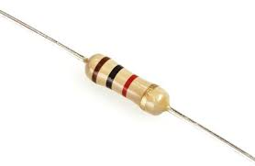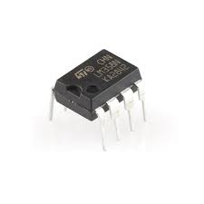

FIGURE 3:LM358 FIGURE 4: 1K RESISTORS

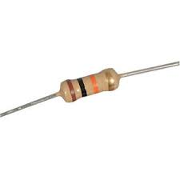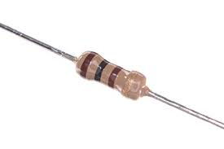

FIGURE 5:100 OHM RESISTORS FIGURE 6:10K RESISTORS

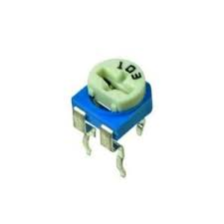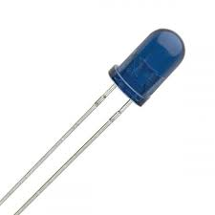

FIGURE 7:IR TX FIGURE 8:10K POTENTIOMETER

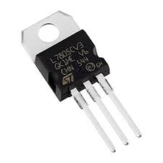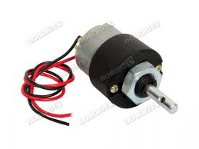

FIGURE 9:DC MOTOR FIGURE 10:IC 7805

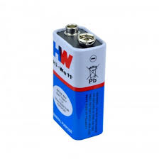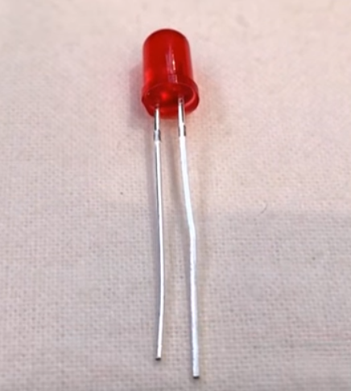

FIGURE 11:LEDS FIGURE 12:9V BATTERY

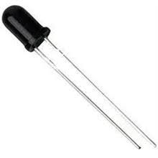

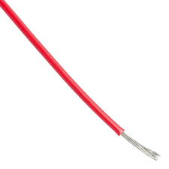

FIGURE 13: IR RX FIGURE 14:WIRES

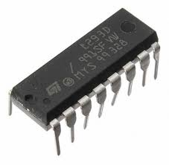

FIGURE 15:IC L293D

**3.2 DETAILS OF COMPONENTS:**

**IR TRANSMITTER:** IR LEDs allow for cheap, efficient production of infrared light, which is electromagnetic radiation in the 700 nm to 1mm range. IR LEDs are useful in a number of types of electronics, including many types of remote controls for televisions and other electronics. Used with infrared cameras, IR LEDs can act like a spot light while remaining invisible to the naked eye.

Because IR LEDs can be used in conjunction with a number of different types of sensors, they are becoming common in machine-to-machine (M2M) environments and Internet of Things (IoT) applications.

**IR RECEIVER:** An **infrared receiver**, or **IR receiver**, is hardware that sends information from an **infrared** remote control to another device by receiving and decoding signals. In general, the **receiver** outputs a code to uniquely identify the **infrared** signal that it receives.

**RESISTORS:** A **resistor** is a passive two-terminal electrical component that implements electrical resistance as a circuit element. In electronic circuits, **resistors** are used to reduce current flow, adjust signal levels, to divide voltages, bias active elements, and terminate transmission lines, among other uses.

**IC 7805:** 7805 is a three terminal linear voltage regulator IC with a fixed output voltage of 5V which is useful in a wide range of applications. Currently, the 7805 Voltage Regulator IC is manufactured by Texas Instruments, ON Semiconductor, STMicroelectronics, Diodes incorporated, Infineon Technologies, etc.

Some of the important features of the 7805 IC are as follows:

* It can deliver up to 1.5 A of current (with heat sink).
* Has both internal current limiting and thermal shutdown features.
* Requires very minimum external components to fully function.

**LEDs:** A light-emitting diode (**LED**) is a semiconductor light source that emits light when current flows through it. Electrons in the semiconductor recombine with electron holes, releasing energy in the form of photons.

**IC L293D:** L293D is a typical Motor driver or Motor Driver IC which allows DC motor to drive on either direction. L293D is a 16-pin IC which can control a set of two DC motors simultaneously in any direction. It means that you can control two [DC motor](https://www.rakeshmondal.info/High-Torque-Motor-Low-RPM-Motor) with a single L293D IC. Dual H-bridge Motor Driver integrated circuit(IC).The l293d can drive small and quiet big motors as well. In a single L293D chip there are two h-Bridge circuit inside the IC which can rotate two dc motor independently. Due its size it is very much used in robotic application for controlling DC motors.

**DC MOTOR:** 100RPM Centre Shaft Economy Series DC Motor is high quality low cost DC geared motor. It has steel gears and pinions to ensure longer life and better wear and tear properties. The gears are fixed on hardened steel spindles polished to a mirror finish. The output shaft rotates in a plastic bushing. The whole assembly is covered with a plastic ring. Gearbox is sealed and lubricated with lithium grease and require no maintenance. The motor is screwed to the gear box from inside.   
Although motor gives 100 RPM at 12V but motor runs smoothly from 4V to 12V and gives wide range of RPM, and torque. Tables below gives fairly good idea of the motor’s performance in terms of RPM and no load current as a function of voltage and stall torque, stall current as a function of voltage.

**CHAPTER 4: IMPLEMENTATION**

**4.1 HARDWARE IMPLEMENTATION:**

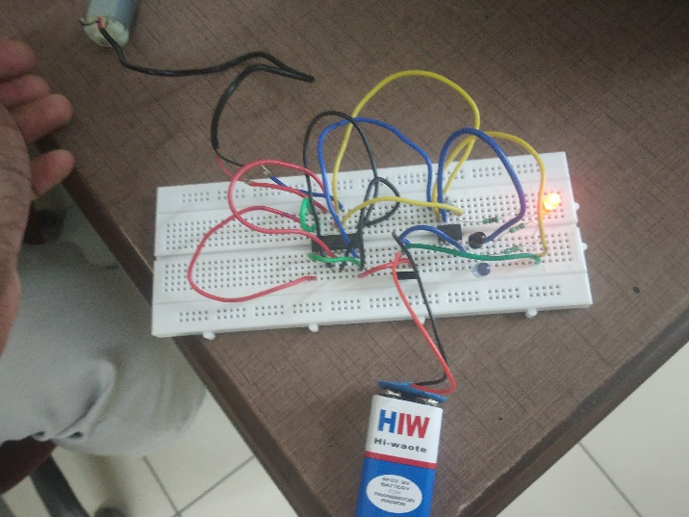

FIGURE 16:bread board

The above image shows the live project when there is presence of OBJECT .There is response as current is generated by the photodiode which ONs the dc motor. ON “Bread Board”.

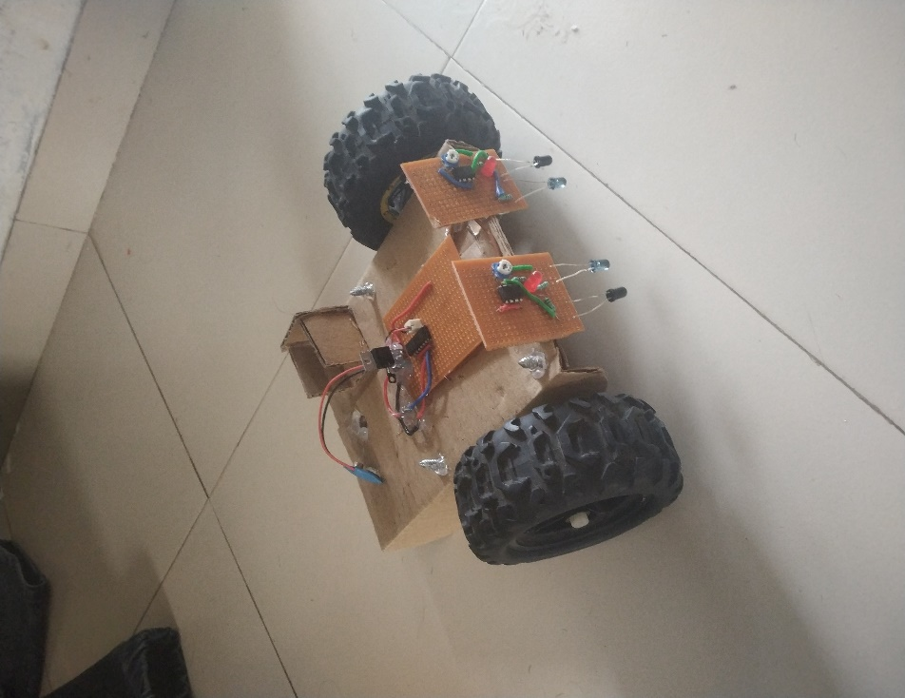

FIGURE 17:on gpcb

The above image shows the live project when there is presence of OBJECT .There is response as current is generated by the photodiode which ONs the dc motor. ON GPCB(general pcb).

**4.2 SOFTWARE IMPLEMENTATION:**

2D VIEW:

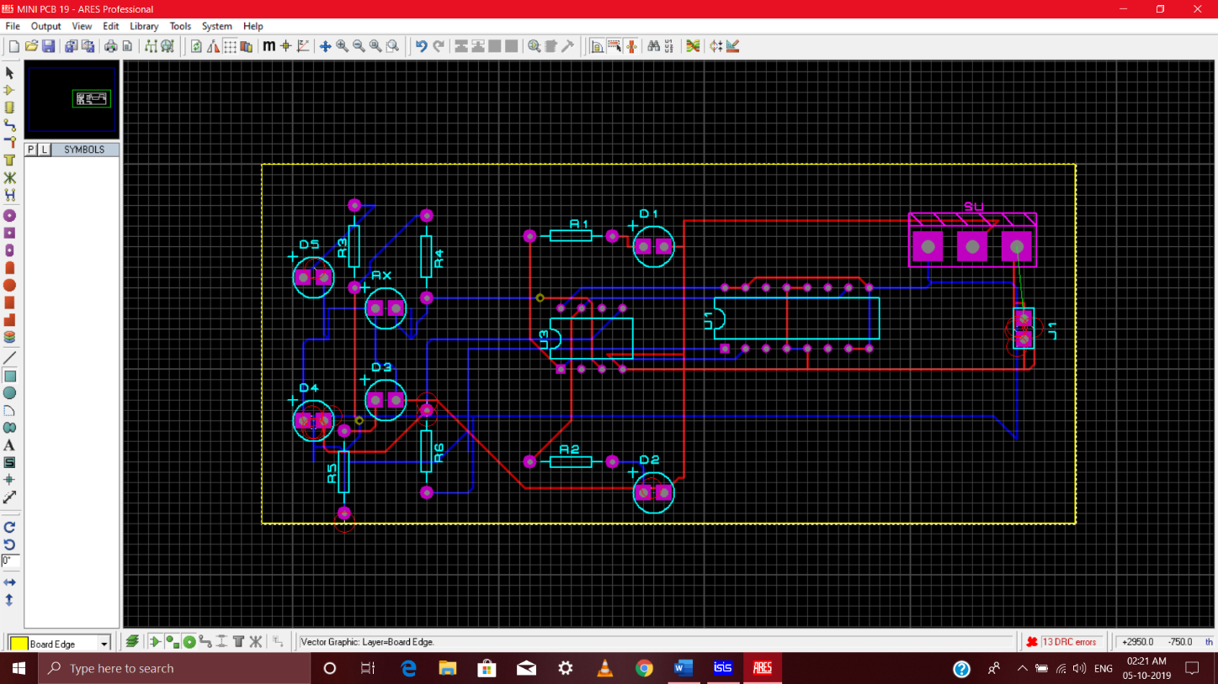

FIGURE 18(a):pcb design

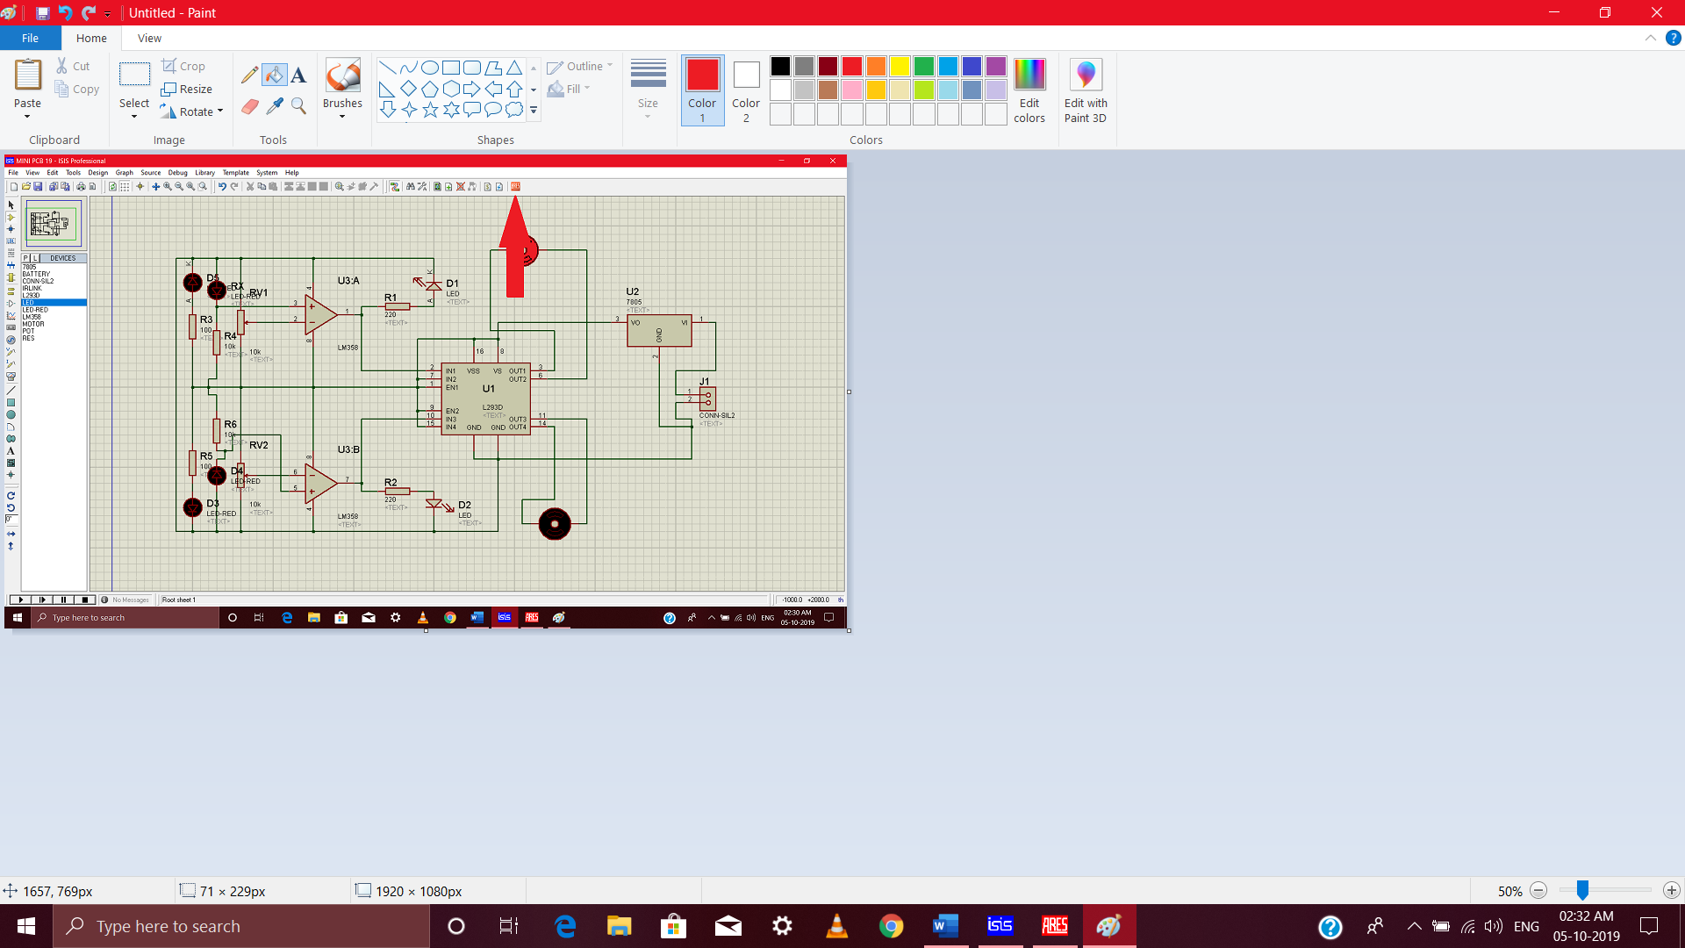STEP 1:

FIGURE 18(b):formation of pcb

After completition of circuit with all components with PCB previews, click on the ARES button.

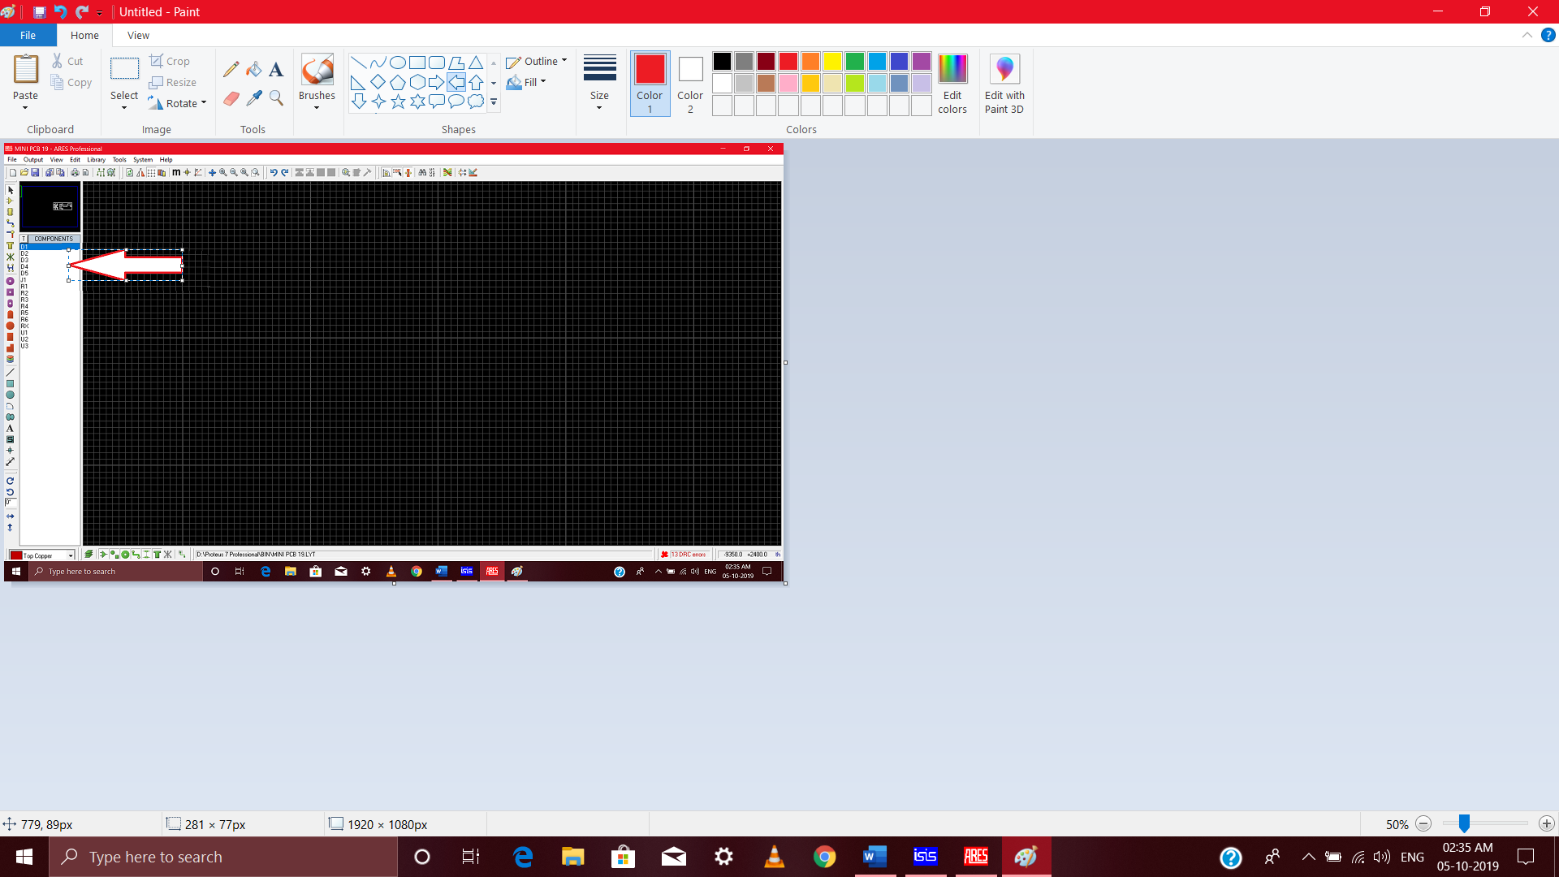STEP 2:

FIGURE 18(c):component selection

Place each component on the board with proper spacing and visuals.

STEP 3: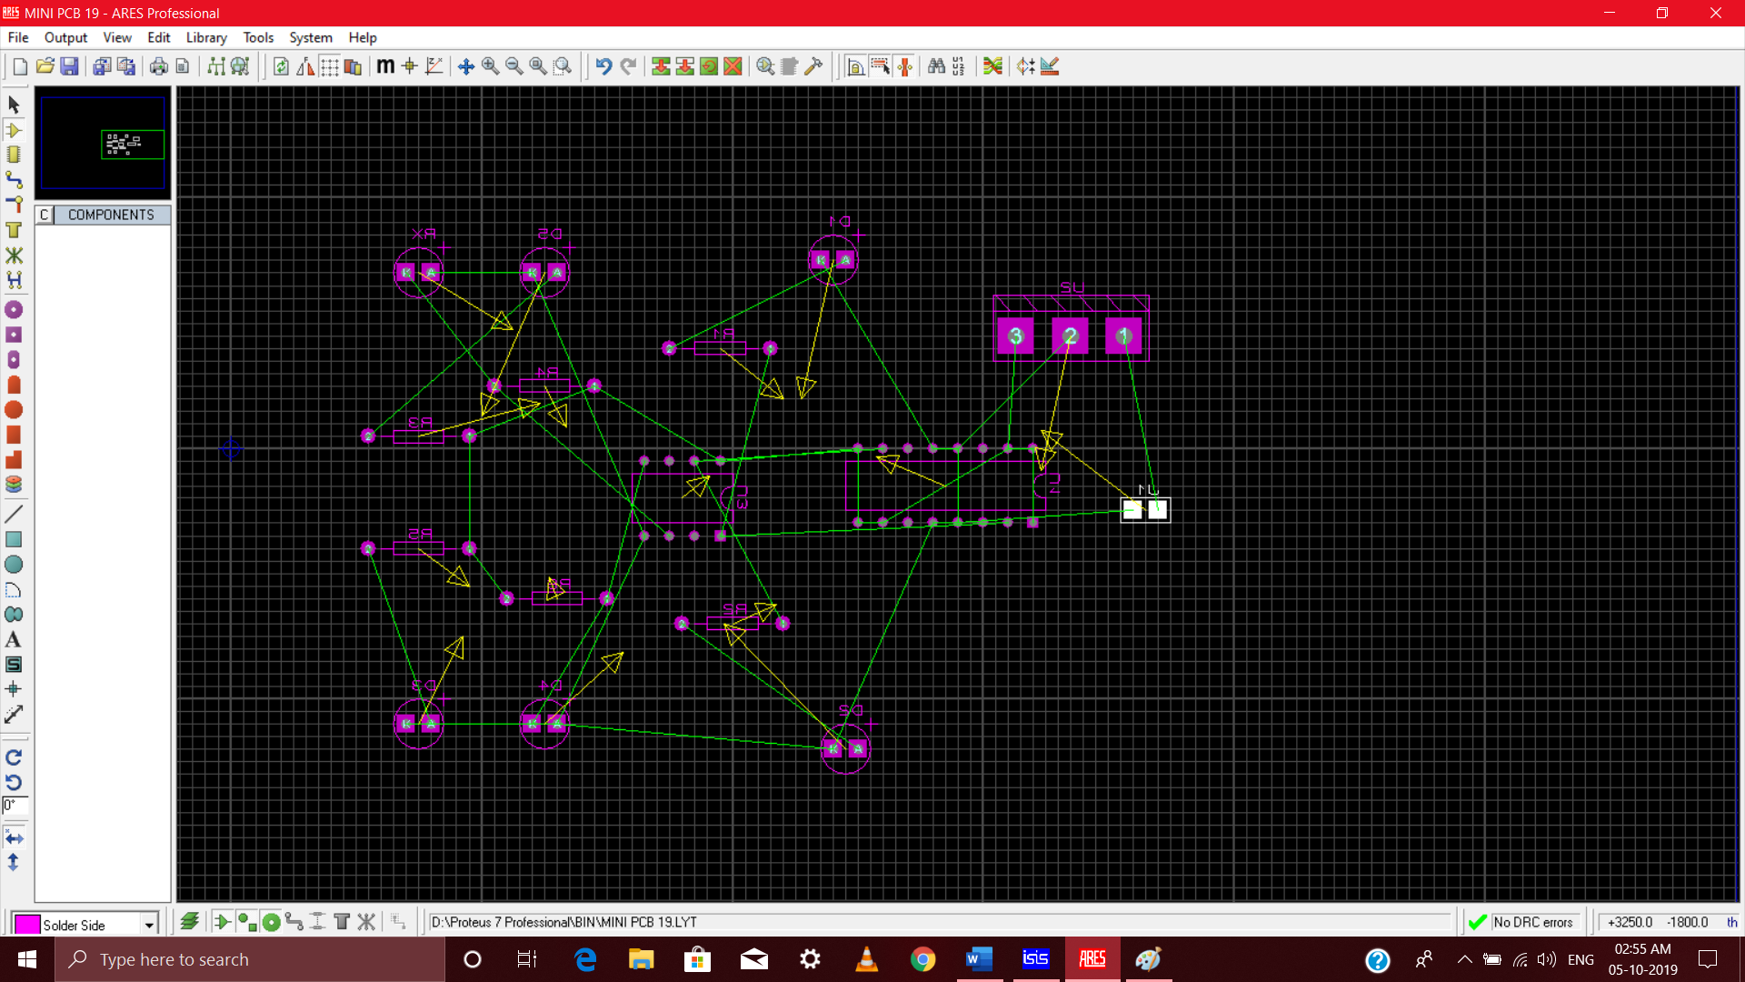

FIGURE 18(d):component setup

It will look like this, you can see the open connections yet to be made. They can be made by auto routing feature.

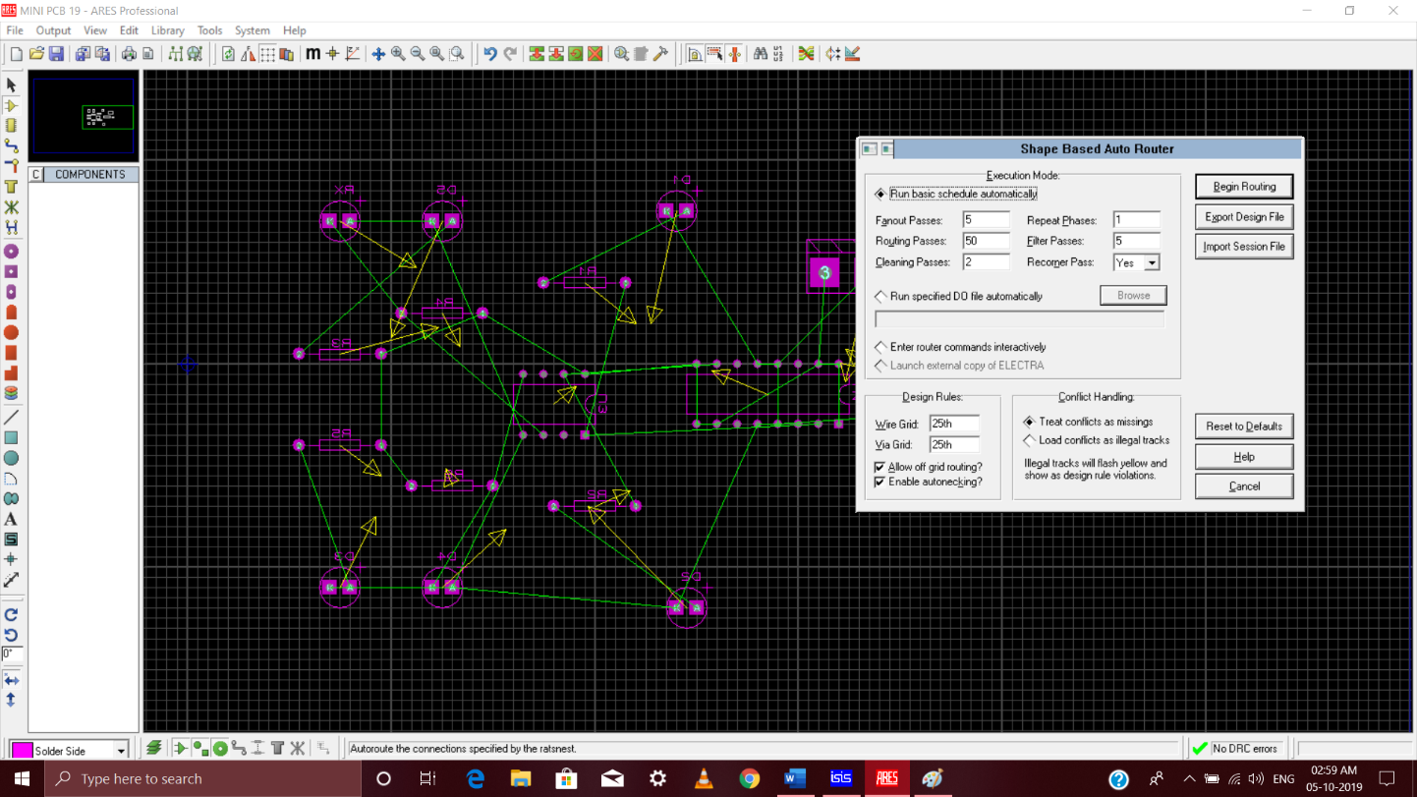STEP 4:

FIGURE 18 (e):auto routing

Press on auto routing and let the process get completed.

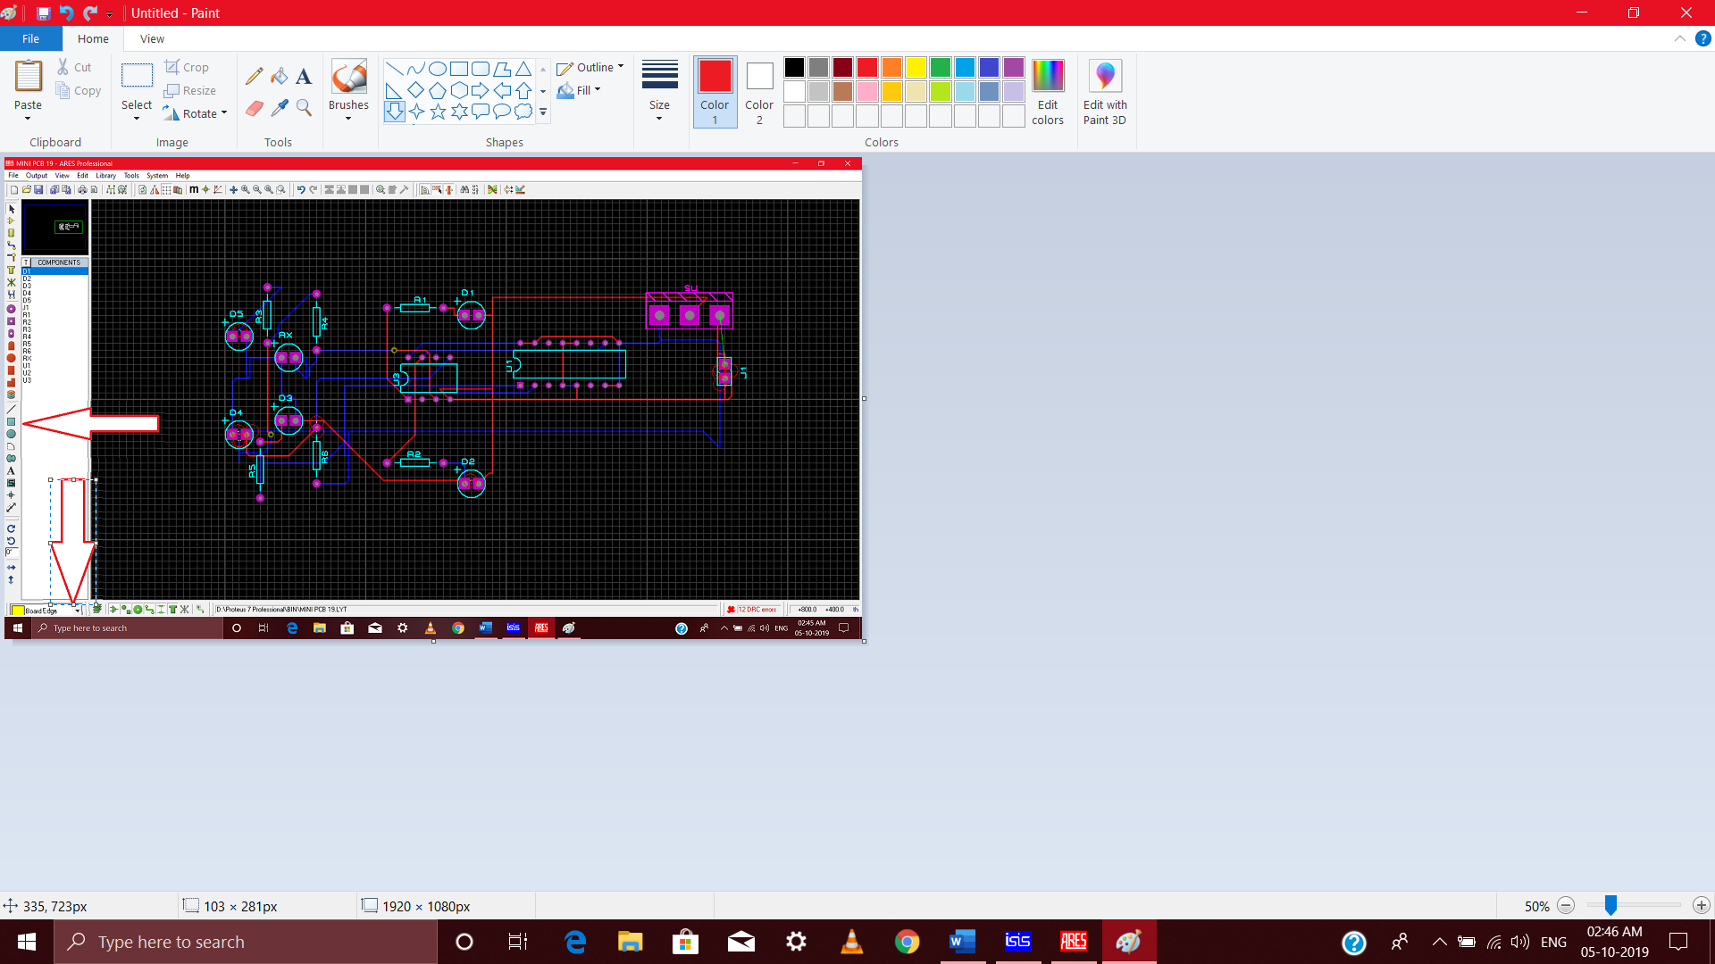STEP 5:

FIGURE 18(f):boarder of pcb

Select the border option and assign the area of your pcb with the same tool.

STEP 6:



FIGURE 18 (g):final pcb design

Final PCB software look alike.

3D VIEW:

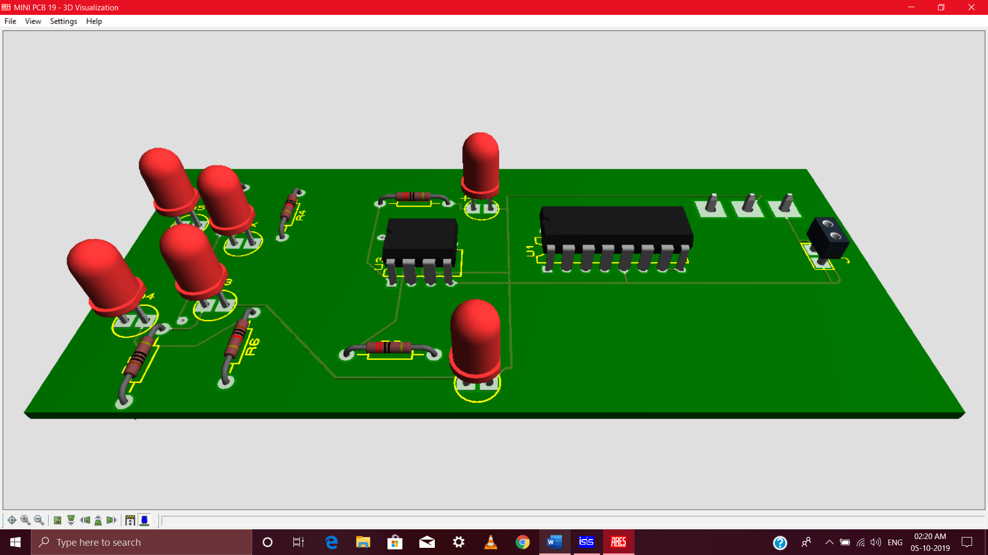

FIGURE 19:3D view of pcb

**CHAPTER 5: APPLICATIONS AND FUTURE SCOPE**

**5.1 APPLICATIONS:**

Robot can replace human’s job in industry because robot can do many things faster than humans. Robots do not need to be paid, eat, drink, or go to the bathroom like people. They can do repetitive work that is absolutely boring to people and they will not stop, slow down, or fall asleep like a human. Individual stationary sensors have limited ranges and applications.

* Used for long distance applications.
* Used for long time and repeated path.
* Used in home, industrial automations as:
  + - * **Industrial Applications**: These robots can be used as automated equipment carriers .
      * **Domestic applications**: These can also be used at homes for domestic purposes like floor cleaning etc.

**5.2 FUTURE SCOPE:**

This smart and intelligent robot can be modified and controlled using Bluetooth, WIFI module and other type of sensors. The movement of the line follower can be controlled either by using a Bluetooth or a WIFI module. By using any of these modules, the line follower robot can be stopped, can be turned right and can be turned left. This makes the line follower robot more intelligent and useful. The line follower cannot be stopped on its path if a Bluetooth or WIFI module is not used. So to stop the robot without placing any other obstacle this idea can be implemented to stop the robot or even to change its path. One more idea which can be implemented on the line follower is to make it a RGB color following robot. The robot will be able to differentiate between these three colors and according to the given instruction it will follow the particular colored path.

**CONCLUSION:**

The line following robot project challenged the group to cooperate , communicate, and expand understanding of electronics, mechanical systems, and their integration. In its current form robot is enough capable. It can follow any curve and cycle. We must build a robot that has light weigh and high speed because points are awarded based upon the distance covered and the speed of the overall robot. Therefore, we used two high speed motors and high sensitivity sensors circuit. The body weight and wheels radius have effects on speed, too. The weight of the designed robot is around 300 gram and it can be lighter. To get better maneuver, we must build a robot that uses two motors and two wheels on the rear and a free wheel on the front.**REFERENCES:**

[1]<https://easyeda.com/TapendraMandal/Line_Following_Robot-a1bb40b34cd14a9186ca10b7a76df764>

[2]<https://www.google.com/search?sxsrf=ACYBGNTqOkHncC3Gf9zWvEGVu2gR0aB0zQ:1570045418237&q=line+follower+robot+project+report+ppt&sa=X&ved=2ahUKEwj-pr37qv7kAhXSW3wKHWRUAqQQ1QIoAHoECAoQAQ&biw=1536&bih=722>

[3][https://www.researchgate.net/publication/327814718_PROJECT_REPORT_LINE_FOLL OWING_ROBOT](https://www.researchgate.net/publication/327814718_PROJECT_REPORT_LINE_FOLL%20%20%20%20%20%20%20OWING_ROBOT)

[4] <https://www.academia.edu/8691722/line_follower>

[5] <https://www.youtube.com/watch?v=ZQjmUt3_ffM&t=1s>

[6]<https://category.alldatasheet.com/index.jsp?sSearchword=5mm%2520led%2520datasheet&gclid=CjwKCAjw29vsBRAuEiwA9s-0B7KkwvQn-0U0Mt28N0oqWxjOhks4zW6TbjWfh0lMmeA6pcie6TBk3BoCqAkQAvD_BwE>

**DATASHEET OF COMPONENTS:**

**IC L293D:**

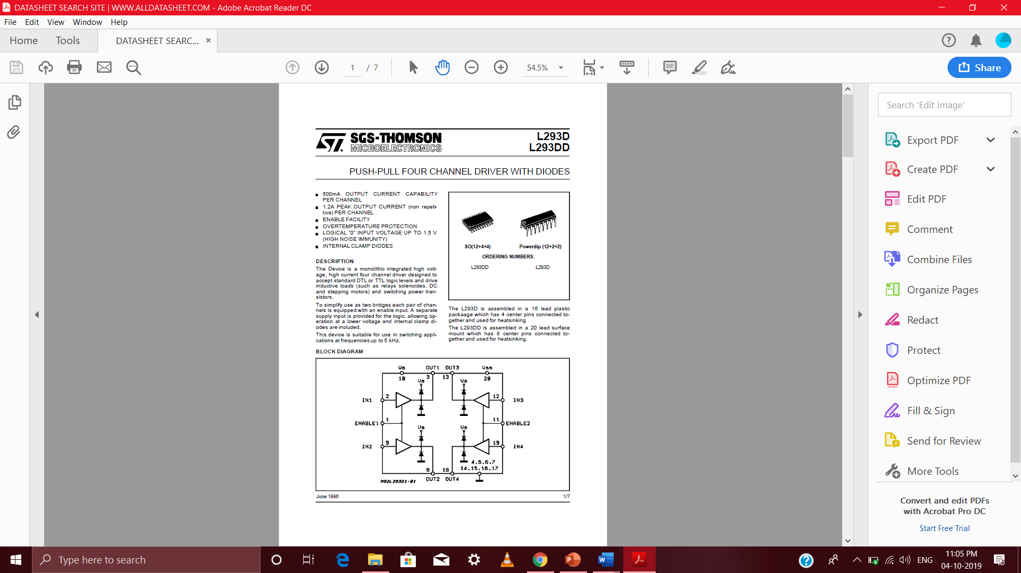

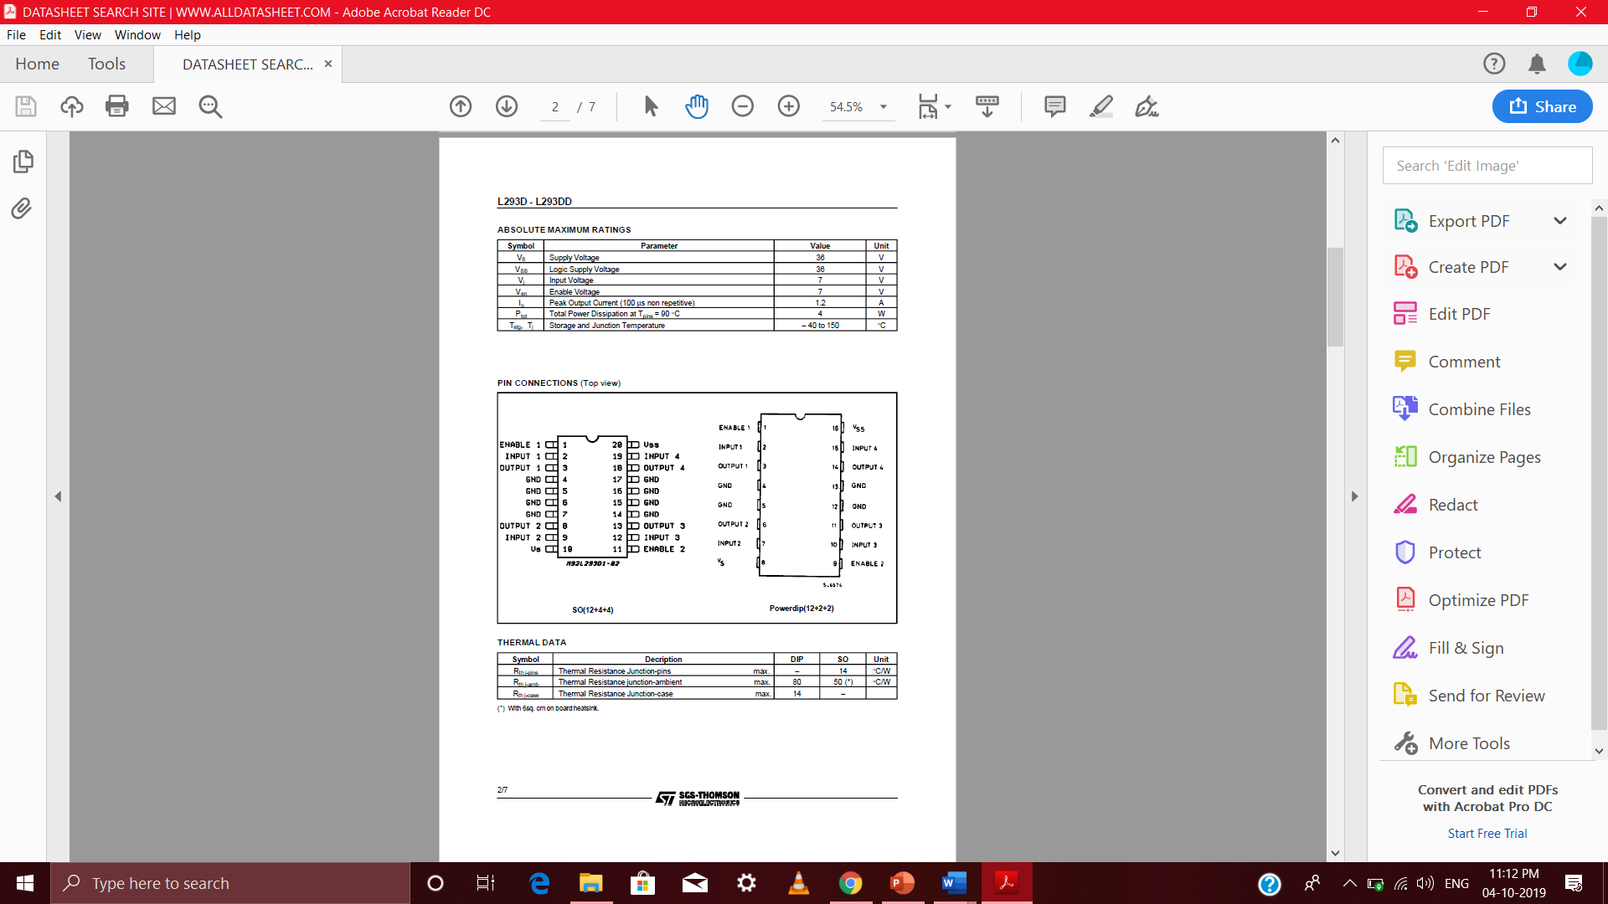

**IC 7805:**

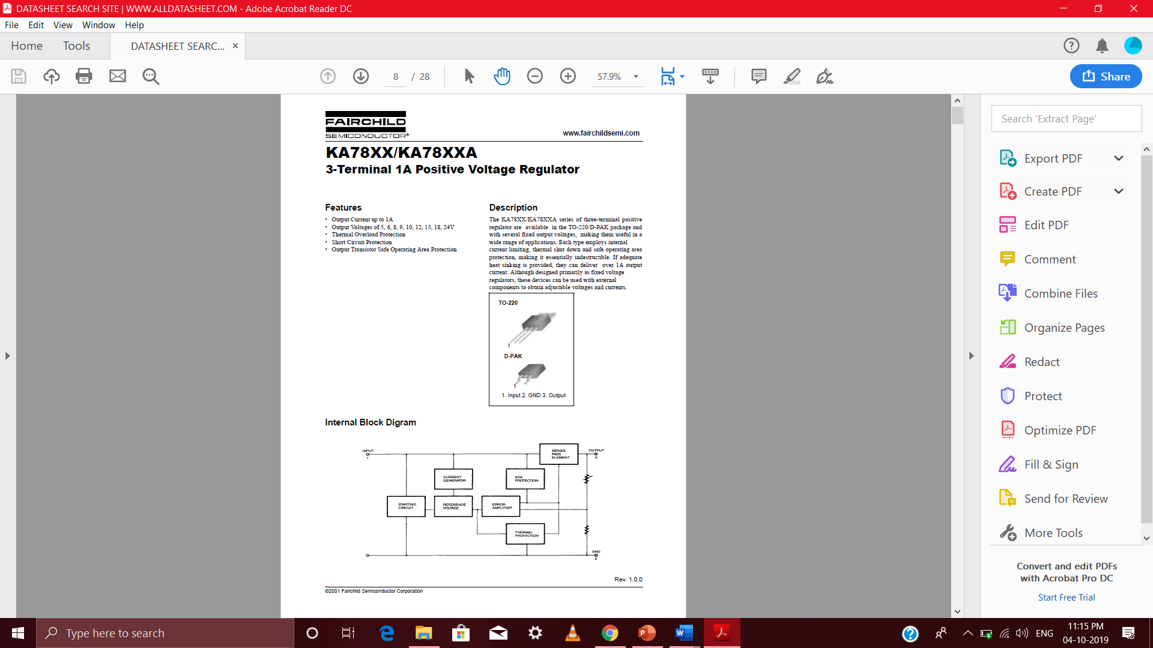

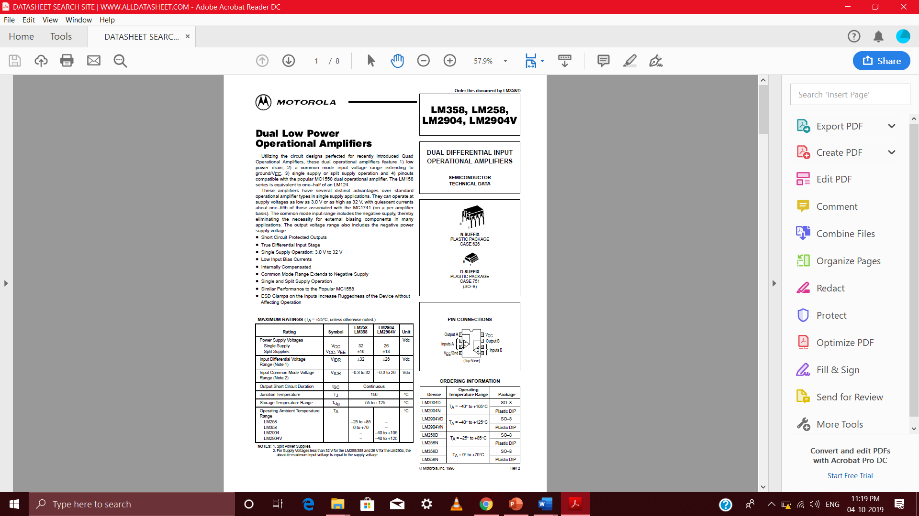**IC LM358:**

**IR TRANSMITTER:**

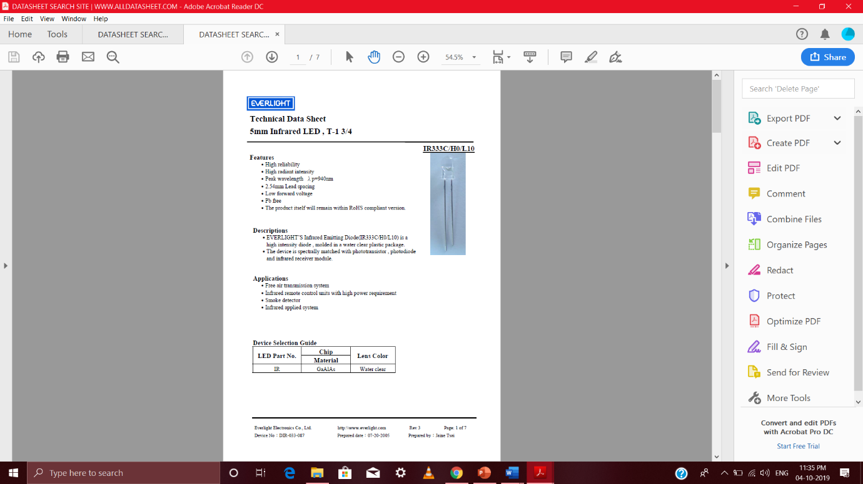

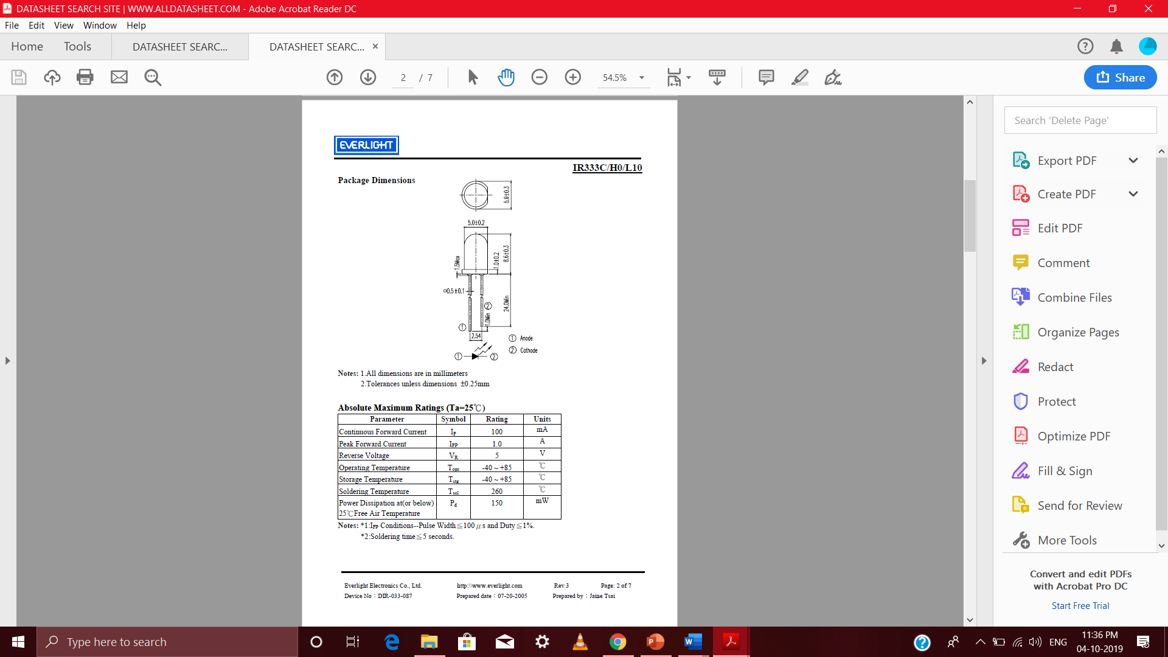

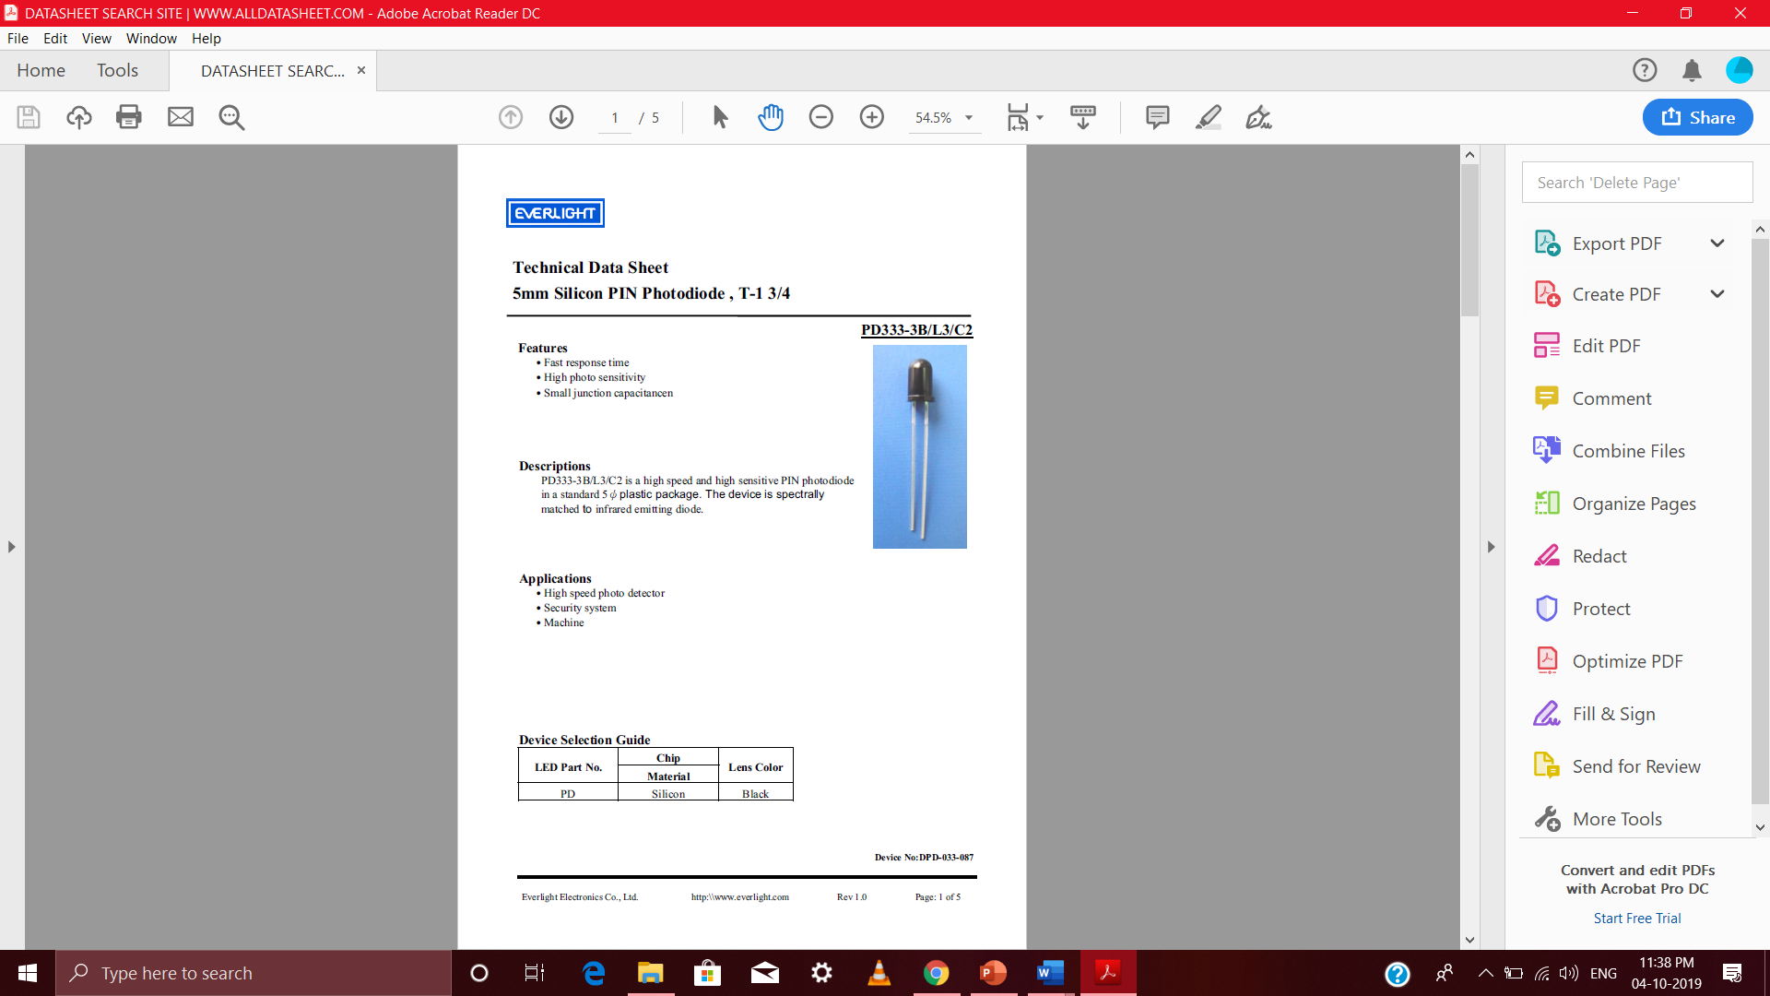**IR RECEIVER:**

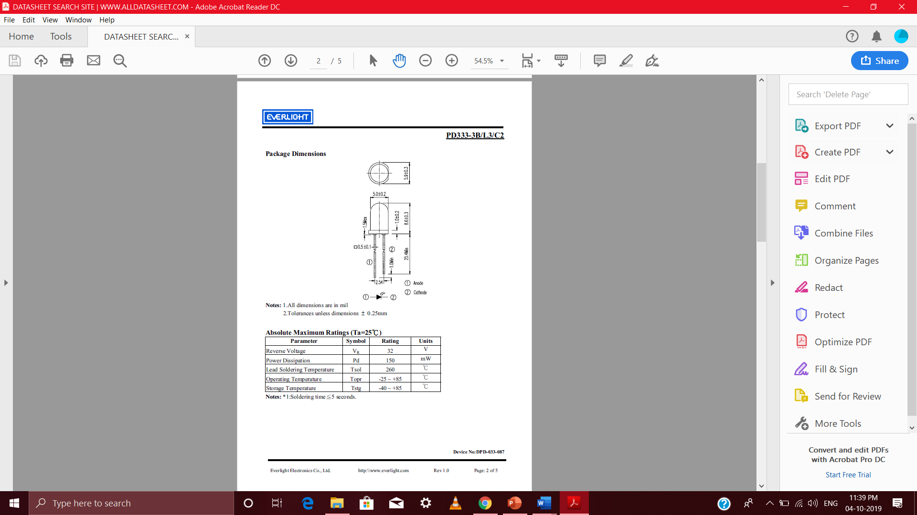

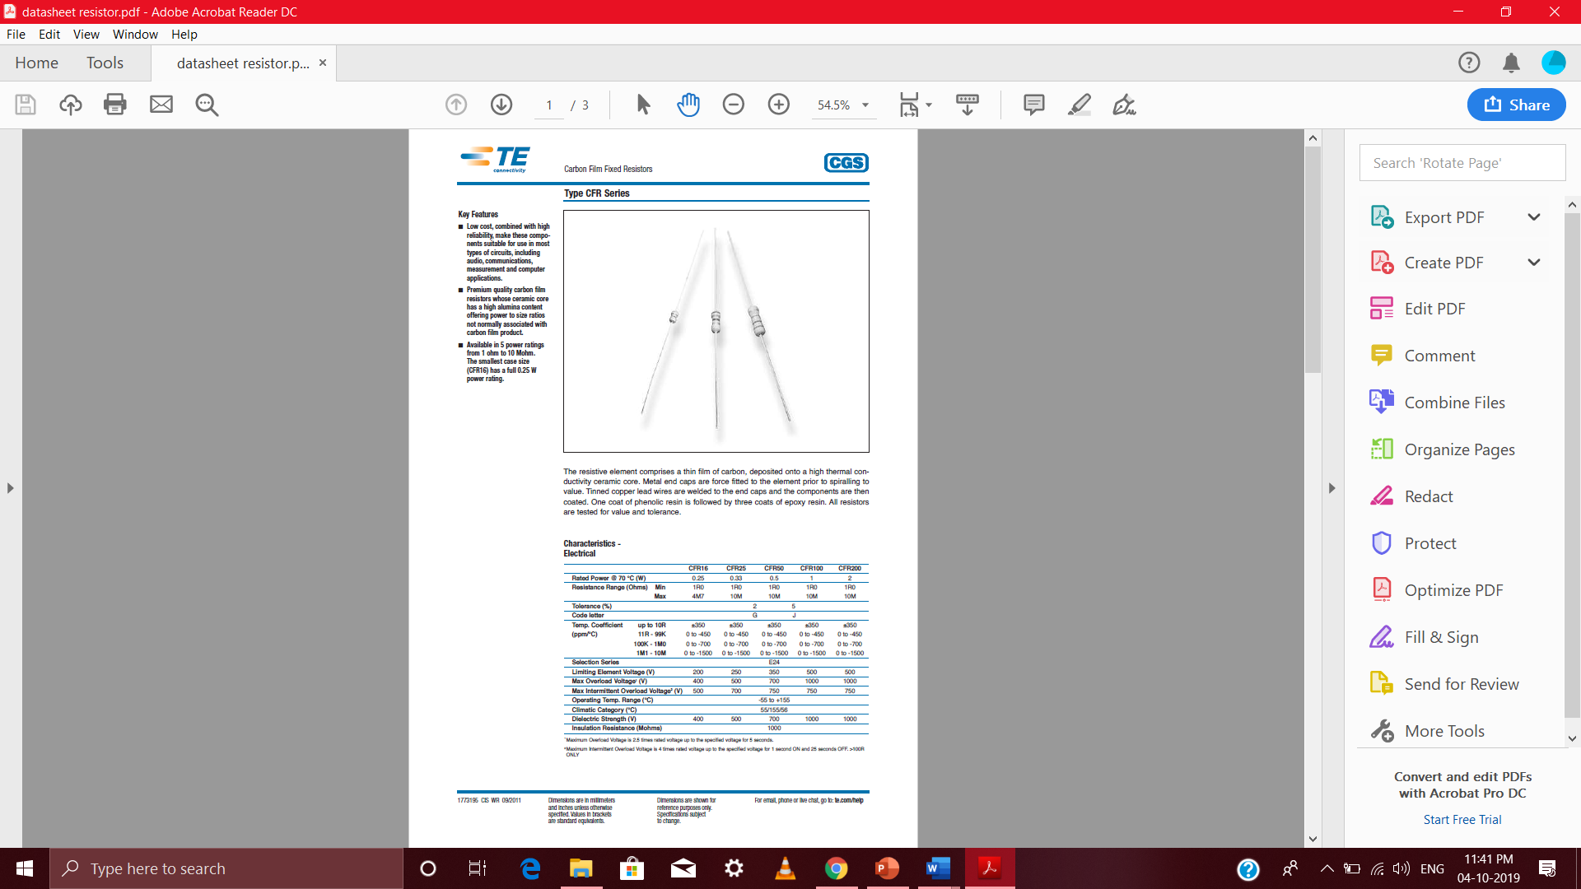**RESISTORS:**

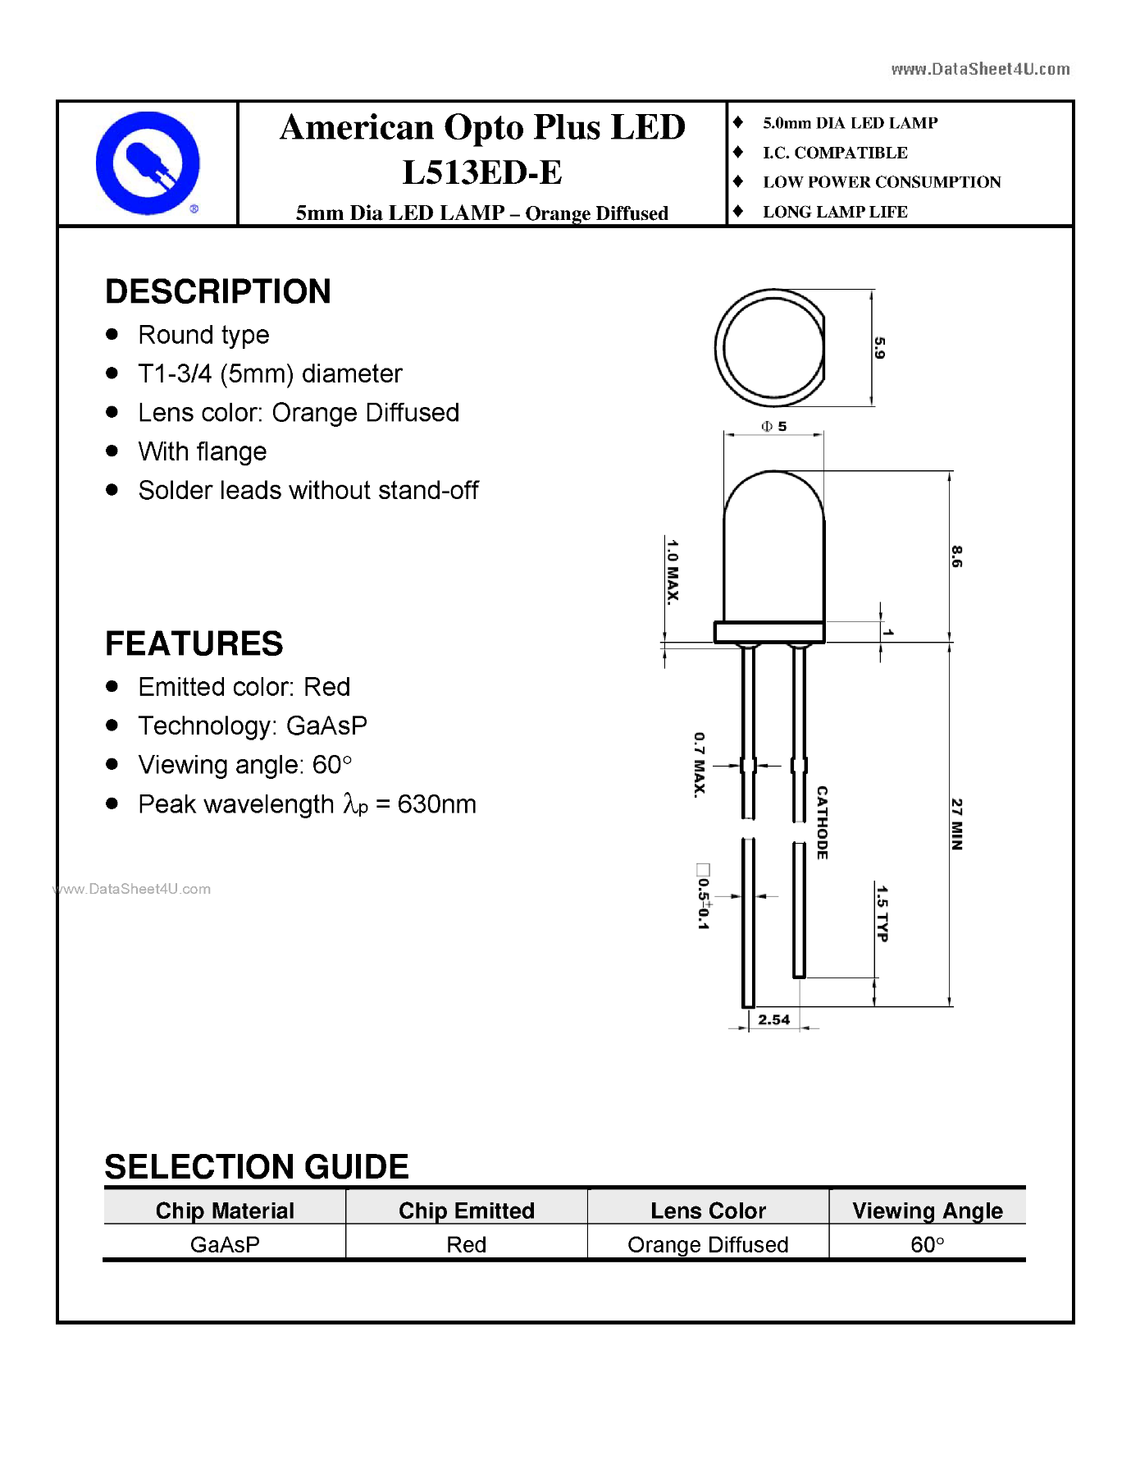**LEDs:**

**1OK POTENTIOMETER:**